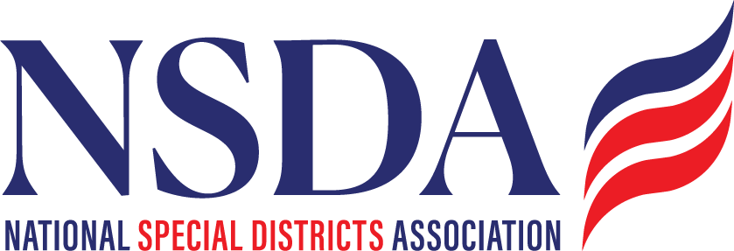

NSDC Federal Advocacy Committee
Summary
10.23.2025
1:00 pm MNT time

Welcome and Updates: Ann Terry
Federal Advocacy Update: Paragon Government Affairs
The committee convened to receive federal updates, discuss pending legislation, and begin shaping the NSDA’s 2026 policy priorities and long-term roadmap.
Paragon provided an overview of the ongoing federal government shutdown and FY 2026 appropriations process. Legislative activity continues at a slow pace, with significant concerns emerging over rising healthcare costs as open enrollment approaches. Members were asked to share any operational impacts of the shutdown—examples noted include Illinois Soil and Water Conservation Districts being unable to access shared federal offices, and delays in U.S. Army Corps of Engineers water testing in Colorado.

Legislative Updates
- H.R. 2766 / S. 2014 (Special Districts Fairness and Accessibility Act): Paragon conducted a Hill tour this week to advance support. Some offices expressed concern about expanding federal dependency; discussion emphasized the importance of focusing advocacy on local efficiency and service delivery, not federal funding. NACo has endorsed the bill, though further movement is unlikely before spring 2026.
- H.R. 4669 (FEMA Coordination): Progress expected to resume in spring 2026. NSDA submitted a letter of support.
- Fix Our Forests Act: Recently advanced out of committee; Reps. Schiff and Bennet voted no.
- H.R. 5078 (Cybersecurity PILLAR Act): Continues gradual movement; NSDA has submitted a support letter.

Other Advocacy Initiatives
- Special Districts House Caucus: Paragon has distributed letters and briefing materials to congressional offices. Members will be notified if state-level outreach is needed.
- Special Districts National Day: Under development.
- 2026 NSDA Fly-In: Dates pending release of the 2026 congressional calendar (anticipated April 27–May 8 window).

Strategic Planning
Committee members reviewed initial feedback on the draft 2026 federal advocacy agenda, which will be finalized for Board consideration in November–December. Additionally, Clark Halvorson (WAWSD) presented his association’s five-year policy roadmap as a model for NSDA’s long-term planning, launching discussion on developing a similar strategic framework.

Next Meeting: To be scheduled, as November and December dates fall on holidays.

Paragon Government Relations Hill visits - October

Wed 10/22
- Senator Ashley Moody R-FL (Wed 10/22 1-1:30)
  - Meeting with Bea Valenti
  - Location: SR-387 Russell Seante Office
- Rep. Pettersen D-CO-07 (Wed 10/22 2-2:30)
  - Meeting with Risa Fish
  - Location: 348 Cannon House
- Rep. Ralp Norman R-SC-05 (Wed 10/22 2:30-3)
  - Meeting with Darcy Sims
  - Location: 569 Cannon House
- Senator John Cornyn R-TX (Wed 10/22 3-3:30)
  - Meeting with Albert Bryson
  - Location 517 Hart Senate Office
- Senator Ruban Gallego D-AZ (Wed 10/22 4-4:30PM)
  - Meeting with Zack Gallego
  - Location: 302 Hart Senate Office
Thurs 10/23
- Fireside chat with Senator Lankford (Thurs 10/23 8-9:15)
  - Agenda
    - Breakfast (8am)
    - Fireside Chat (8:30-9am)
    - Networking (9-9:15am)
  - Location: American Trucking Association; 430 1st street, Suite 100
- Rep. Pat Fallon R-TX-04 (Thurs. 10/22 10:30-11AM)
  - Meeting with Rohan Suri
  - Location: 2416 Rayburn
- Rep. Ken Calvert R-CA-41 (Thurs. 10/23 11-11:30)
  - Meeting with Jack Lincoln
  - Location: 2205 Rayburn
- Placer County Business Association Summit (Thursday 10/23 noon-3PM)
  - Agenda
    - Lunch (12-1:15)
    - Speakers (1:15-2:15)
    - Speaker James Zandstra (2:15-3PM)
  - Location: Kimpton Hotel Monaco, 700 F St. NW
- NSDA Monthly Leg Call (Thursday 10/23 3-4PM)
  - Agenda:
  - Location: Zoom Call
- Senator Hickenlooper D- CO (Thursday; 10/23 4:30-5PM – TEAMS CALL)
  - Meeting with Christine Chang
  - Location: Teams Call
  - Phone: 202-224-5941

Friday 10/24
- Senator Tim Scott R-SC (Friday 10/24; 10:30-11am)
  - Meeting with Sam Llewellyn
  - Location: 104 Hart Building
  - Phone: 202-224-6121
- Rep. Mike Flood R-NE-01(Friday, 10/24; 11-11:30) Pending
  - Meeting with Joshua McGuire
  - Location: 343 Cannon House Building
- Rep. Kevin Kiley R-CA-03 (Friday 10/24 12-12:30)
  - Meeting with James Zandstra
  - Location: 2445 Rayburn
- Rep. Paul Gosar R-AZ-09 (Friday 10/24 1:30-2PM)
  - Meeting with Connor Sloan and Macayle Fuchs
  - Location: 2057 Rayburn

Monday 10/27
- Senator Rick Scott R-FL (Monday 10/27 3:30-4PM)
  - Meeting with Emily Dudley
  - Location: 110 Hart Senate
- Rep. Fong R-CA-20 (Monday 10/27; 4-4:30PM)
  - Meeting Kati Albiani
  - Location: 243 Cannon House

