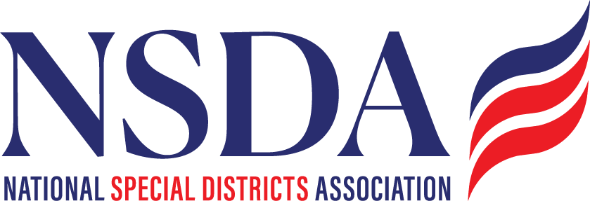

Janis C. Reyes
Assistant Chief Counsel, Labor and Immigration
SBA Office of Advocacy
409 3rd Street SW, Suite 3300
Washington, DC 20416
Dear Ms Reyes:

On behalf of the National Special Districts Association (NSDA), thank you for the opportunity to provide feedback regarding the impacts on small entities of federal Web Content Accessibility Guidelines (“WCAG” 2.1) adopted under Title II of the Americans with Disabilities Act (“ADA”), in particular on special districts. We appreciate the thoughtful approach the U.S. Small Business Administration (“SBA”) Office of Advocacy is taking to better understand implementation challenges and opportunities associated with these important accessibility standards.
NSDA represents and advocates for thousands of special districts nationwide that provide essential public services, including fire protection, water and wastewater services, libraries, parks and recreation, cemeteries, mosquito control, health services, and other critical local functions. While some special districts are large and well-resourced, many are exceptionally small local government agencies that operate with limited budgets, volunteer boards, and little or no dedicated staff.
For example, the Ouray County Cemetery District in Colorado operates with an annual budget of approximately $3,000, yet it is expected to comply with the same complex WCAG requirements as large metropolitan utility districts with substantial staffing and technology resources. This disparity illustrates the significant implementation burden many small local governments face and exists in states and communities throughout the country.
NSDA helps special districts better understand accessibility obligations and identify affordable, practical compliance solutions. We appreciate the federal government’s recent extension of implementation deadlines, which provides valuable additional time for special districts working in good faith to comply.
Based on feedback from our members and implementation experience, we respectfully offer the following recommendations for consideration:
- Establish a reasonable “ cure period process for accessibility complaints. Local governments should have the opportunity to promptly correct identified issues and communicate remediation efforts to the individual raising concern before enforcement actions or penalties proceed. And recognizing organizations that demonstrate good-faith efforts through an accessibility statement and a clear process for accommodation requests and reporting issues would be helpful.
- Allow reasonable accommodation flexibility for PDF and archived document requests. Many small special districts lack the capacity to immediately remediate extensive historical records and should be permitted to provide accessible versions upon request within a reasonable timeframe:
- For documents, an explicit statement that accessible HTML versions may be an acceptable compliance pathway when they are substantially accurate, downloadable, provide equivalent functionality, and are paired with responsive assistance for more complex content.
- For archived content, additional language around records retention, transparency, and historical preservation obligations would be helpful. We're still seeing some agencies advised to remove large amounts of content, which may not always be appropriate depending on their legal obligations.
- Permit the use of automated closed captioning technologies as an acceptable compliance option, particularly for small local governments with limited financial and staffing resources.
- Clarify that public meetings may utilize a moderator or staff member to address accessibility-related questions and requests in real time during virtual or hybrid meetings.
- Provide reasonable flexibility for social media cross-posting and promotional content. Small local governments should be permitted to use standard text and cross-platform content distribution practices when accessible information is otherwise maintained on the entity’s official ADA-compliant website.

We appreciate the SBA Office of Advocacy’s willingness to gather stakeholder input and consider practical implementation challenges facing small governmental entities. NSDA and our members would welcome continued dialogue and opportunities to assist in identifying balanced, workable solutions that advance accessibility while remaining achievable for small local governments.
Thank you for your consideration and your ongoing work on behalf of special districts nationwide.
Sincerely,
Chantal
Chantal Unfug
National Director, Public Affairs, Outreach and Engagement
National Special Districts Association

