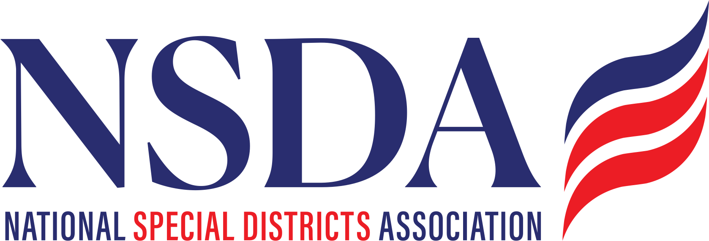

ACTION ALERT
Special District Fairness and Accessibility Act (H.R. 2766)
October 2, 2025

Representatives Pat Fallon (R-TX) and Brittany Pettersen (D-CO) introduced the bipartisan Special District Fairness Act (SDFA; H.R. 2766). The bill will codify a first-ever, formal definition of “special district” and would require the White House Office of Management and Budget (OMB) to issue guidance to federal agencies requiring special districts to be recognized as local governments for the purpose of accessing Federal programs and to create consistence among Federal agencies.

As of October 2, 2025, H.R. 2766 has fifteen (15) co-sponsors that include: Rep Pettersen (D-CO); Rep. David Valadao (R-CA); Rep. Young Kim (R-CA); Rep. Doug LaMalfa (R-CA); Rep. Dan Newhouse (R-WA); Rep. Jay Obernolte (R-CA); Rep. Josh Harder (D-CA); Rep. Suzanne Bonamici (D-OR); Rep. Raul Ruiz (D-CA); Rep. Andrea Salinas (D-OR); Rep Val T. Hoyle (D-OR); Rep. George Whitesides (D-CA); Rep. Ken Calvert (R-CA); Rep. Janelle S. Bynum (D-OR); and Rep. Vince Fong (R-CA).

Requested Action
- All Special District stakeholders are encouraged to send a Co-Sponsor request letter to their congression members.
- Special districts and partnering stakeholders with a direct connection to Kentucky/Senator Rand Paul are urged to contact Senator Paul’s office to urge him to support H.R.2766

Additional Background & Talking Points
H.R. 2766 will:
- Establish a first-ever, formal definition of “special district” in federal law; and,
- Require OMB to issue guidance to federal agencies requiring special districts to be recognized as local governments for the purpose of federal financial assistance determinations.

- According to the Congressional Budget Office (CBO), enacting H.R.2766 would not affect direct spending or revenues (the bill is cost-neutral).
- Special districts are ineligible for – or have barriers to accessing – federal programs due in part to the fact that the U.S. Census Bureau does not recognize special districts as geographic units of government due to the absence of a formal statutory definition. Moreover, special districts do not qualify for certain discretionary grants due to a lack of consistent program guidance among federal agencies.
- Examples of program ineligibility / barriers to access include:

  - Transportation Alternatives / Rails-to-Trails
  - USDOT’s Reconnecting Communities Program
  - U.S. Department of Agriculture (USDA) Rural Housing Preservation Grants
  - U.S. Environmental Protection Agency’s (EPA) Clean-Heavy Duty Vehicles Program

