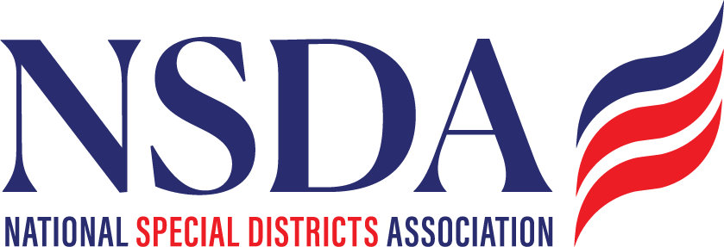

**NSDC Federal Advocacy Committee**

**Agenda**

**4.24.2025**

**1:00 pm MNT time**

*Join Zoom Meeting: https://us06web.zoom.us/j/85240694788?pwd=cFaB1TfCFa370f9hHB8T7easZI2uc1.1*

*Meeting ID: 852 4069 4788*

*Passcode: 818259*

*One tap mobile*

*+17193594580,,85240694788#,,,,*818259# US*

*+13462487799,,85240694788#,,,,*818259# US (Houston)*

**Welcome and Updates:** **Chantal Unfug**

* Welcome

**Federal Advocacy Update: Paragon Government Affairs**

**General DC Overview**

* General DC Overview - Congress is on Recess; Reconvening the Week of April 28
* Legislative Outlook - Budget Reconciliation
  + Potential offsets (Tax-exempt municipal bonds; associations/nonprofit organizations)
* Introduction of the *Special District Fairness and Accessibility Act* (H.R. 2766)
  + Call to Action
* *Water Systems PFAS Liability Protection Act*
* *Fix our Forest status*
* *Tax exemption/Non Profit status*
* Other Business
* NSDA DC Fy-in
* Next meeting date: May 22, 2025