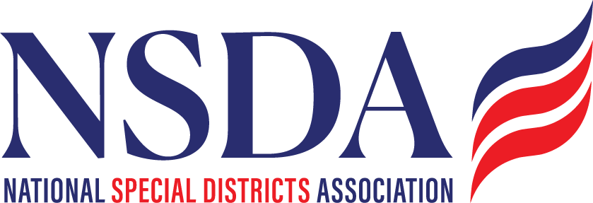

NSDA Federal Advocacy Committee Agenda
2.26.26 1:00 pm MNT time

https://us06web.zoom.us/j/85240694788?pwd=cFaB1TfCFa370f9hHB8T7easZI2uc1.1

Meeting ID: 852 4069 4788 Passcode: 818259
One tap mobile
+17193594580,,85240694788#,,,,*818259# US
+13462487799,,85240694788#,,,,*818259# US (Houston)

Welcome and Updates: Chantal Unfug
Federal Advocacy Update: Paragon Government Affairs
- General Overview
- Special District Fairness and Accessibility Act
- House Farm Bill Markup
- Status of Key Reauthorizations
  - Water Resources Development Act
  - Clean Water & Drinking Water State Revolving Funds
  - Surface Transportation Programs
- Permitting Reform
- Bipartisan Housing Legislation
- Energy Choice Act
- DC Days – Fly in: May 4,5,6,7 (same hotel – Navy Yard, block)
  - We need to confirm who is going to DC.
  - Put your cell phone in the chat.
  - Start Date: Sunday, May 03, 2026
  - End Date: Friday, May 08, 2026
  - Hotel(s) offering your special group rate:
AC Hotel Washington DC Capitol Hill Navy Yard for 349.00 USD per night - Last Day to Book : Saturday, April 04, 2026
  - Book your group rate for NSDA DC Fly In 2026

Members’ new items questions or discussion
- Rural Health Transformation program process by States
- FEMA/DHS
- NARD DC attendance

Background:
California has been allocated $233 million through the new Rural Health Transformation Program. The healthcare/hospital districts themselves don't know how these funds will be allocated. While hospitals apply to the State for these funds, according to one of our hospital CEOs, the feds have to approve the grant after the State does. The CEO said when more details are sought:

- Nobody can find an authority on the step-by-step process.
- Nobody knows the timeline for the process, or how or when the funds will be delivered.
- Nobody knows for sure if the funds will be considered general funds or otherwise.

One of our field team members reports that our healthcare/hospital districts laugh when they mention the program and then ask how to find out more information about how the funds will be delivered and timelines. Is this something NSDA could inquire about?

https://www.oregon.gov/oha/HPA/HP/Pages/rural-health-transformation.aspx

Additional Background from their field notes:

I met with the CEO and a few members of her staff. As recent as July, they had a private medical group ready to partner with their hospital, but they pulled out due to Medicaid cuts at the federal level. They are very aware of the Trump administration's "Rural Health Transformation Program". California is due to receive $233,000,000 for rural hospitals. However, the CEO informed me that finding out how this money will be distributed and timelines for distribution is "impossible" to find out. They recently found out they do apply to the State for funds, but the feds have to approve this funding. The money also won't come to them as general funds, and as of today there seems to be no structure for distributing these funds. They also mentioned at the state level, the Office of Healthcare Affordability, created by SB 184 in 2022 has put caps on how much hospitals can profit. There are eight hospitals that ranked as the most expensive in the state and must cap profits at 1.8%. Other hospitals have to cap their profits at 3%. This is having a domino effect on their hospital. Many patients get transferred from the healthcare district to these "most expensive" hospitals, but having to cap profits means the "most expensive" hospitals are closing service lines. This means smaller hospitals won't be able to transfer patients to these top hospitals. The CEO pointed out that the state limits how much profit a hospital can make, but insurance companies don't have this limitation. They said it's not hospitals driving up costs, but insurance companies. They have a close relationship with their state and federal lawmakers’ offices, meeting with them on an almost weekly basis. They took advantage of a State of CA program called the "Distressed Hospital Program." The healthcare district and 17 other hospitals took advantage of this program, but the healthcare district was designated as no longer distressed and has to pay back the funds that came to them which makes them distressed again. They are working with legislators to make this program a grant instead of a payback. Their Congressional representative is also making calls to state legislators to make this program a grant.

“I’m wondering if districts/agencies in other states are having similar issues/trouble with federal funding that have popped up for us. We have an approved FEMA Hazard Mitigation Grant and dollars are at CalOES. But plans have to be approved by DHS and we’re hearing that’s taking a year or more. Without that approval we can’t move on to the project construction and that is unlikely to happen before the period to perform closes in February 2027. So we may lose out on $30 million for construction due to the feds not approving and not automatically extending the period of performance deadline that has usually happened in the past. We know others in CA have similar issue, but wonder if this is happening elsewhere since any changes at Congressional level would likely require help/interest from Republican congress members in CA and in Red states.”

Freedom Caucus members: Freedom Caucus Members:
Rep. Lauren Boebert (R-CO)
Rep. Andy Biggs (R-AZ)
Rep. Eli Crane (R-AZ)
Rep. Paul Gosar (R-AZ)
Rep. Chip Roy (R-TX), Policy Chair
Rep. Michael Cloud (R-TX)
Rep. Brandon Gill (R-TX)
Rep. Keith Self (R-TX)
Rep. Ralph Norman (R-SC), Vice Chair
Rep. Sheri Biggs (R-SC)
Rep. Byron Donalds (R-FL)
Rep. Scott DesJarlais (R-TN)
Rep. Diana Harshbarger (R-TN)
Rep. Andy Ogles (R-TN)
Rep. Andy Harris (R-MD), Chair
Rep. Jim Jordan (R-OH), Co-Founder
Rep. Nick Begich (R-AK)
Rep. Josh Brecheen (R-OK)
Rep. Eric Burlison (R-MO)
Rep. Ben Cline (R-VA)
Rep. Andrew Clyde (R-GA)
Rep. Russ Fulcher (R-ID)
Rep. Morgan Griffith (R-VA)
Rep. Mark Harris (R-NC)
Rep. Clay Higgins (R-LA)
Rep. Mary Miller (R-IL)
Rep. Barry Moore (R-AL)
Rep. Bob Onder (R-MO)
Rep. Scott Perry (R-PA)
Rep. Marlin Stutzman (R-IN)
Rep. Tom Tiffany (R-WI)

