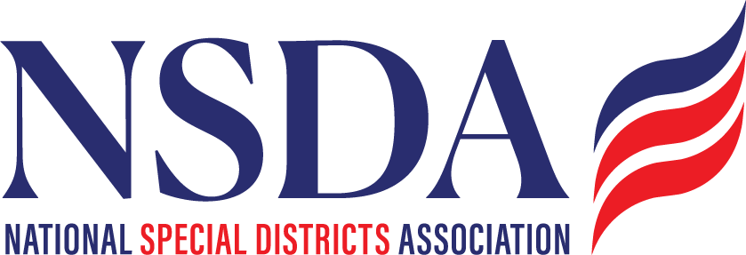

NSDC Federal Advocacy Committee Agenda
12.18.25 1:00 pm MNT time

https://us06web.zoom.us/j/85240694788?pwd=cFaB1TfCFa370f9hHB8T7easZI2uc1.1

Meeting ID: 852 4069 4788 Passcode: 818259
One tap mobile
+17193594580,,85240694788#,,,,*818259# US
+13462487799,,85240694788#,,,,*818259# US (Houston)

Welcome and Updates: Ann Terry
Federal Advocacy Update: Paragon Government Affairs
- General update
- HR2766/S2014 Brass Tacts Update: How do we fine-tune our push through February? Can each organization report on their outreach? Discuss targets, Overview of Kentucky - should we do that in other states?
- Other Issues to mention and decide if we want to push out communication to our members, take positions, or provide input to the committees:
  - David Ulbricht - Public Finance Network Issues to discuss taxation on overtime. Statement?
  - Rural Health Transformation Program – Draft Letter attached
  - Opiod Settlement Process and Funds
  - Streamlining Permitting Bill - The SPEED Act
  - Cyber Security reauthorization - The PILLAR Act
  - New “WOTUS” definition – Waters of the US
- DC Days – Fly in: May 4,5,6,7 (same hotel – Navy Yard)
- ASAE (Chantal will include this information in next weeks Digest on Monday)
- Proposed changes to Monthly meetings in 2026 to include Grants Advocacy and Issues Roundtable by member states.

Members’ new items questions or discussion

