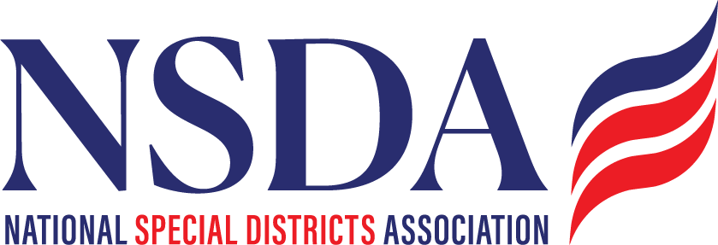
NSDA Federal Advocacy Committee Agenda
4.23.26 1:00 pm MNT time

https://us06web.zoom.us/j/85240694788?pwd=cFaB1TfCFa370f9hHB8T7easZI2uc1.1
Meeting ID: 852 4069 4788 Passcode: 818259
One tap mobile:
+17193594580,,85240694788#,,,,*818259# US
+13462487799,,85240694788#,,,,*818259# US (Houston)

Welcome and Updates: Ann Terry

Federal Advocacy Update: Manatt Phelps and Phillips, LLC & Chantal Unfug
Special District Fairness and Accessibility Act of 2026
Special Districts’ Days in DC: Review Itinerary & National Special District Day May 6 marketing

Issues/Hot topics:
Congressional Budget and Appropriations
Timeline
Political dynamics - reconciliation
Federal grants
New tax policy (including those affecting non-profits)

High-level Authorizations Update
Farm Bill
Surface Transportation
Fix our Forests/Firefighting
Permitting reform
WRDA / water infrastructure

Agency and Admin Actions
Forest Service Reorganization
Final FEMA Review Council Meeting

