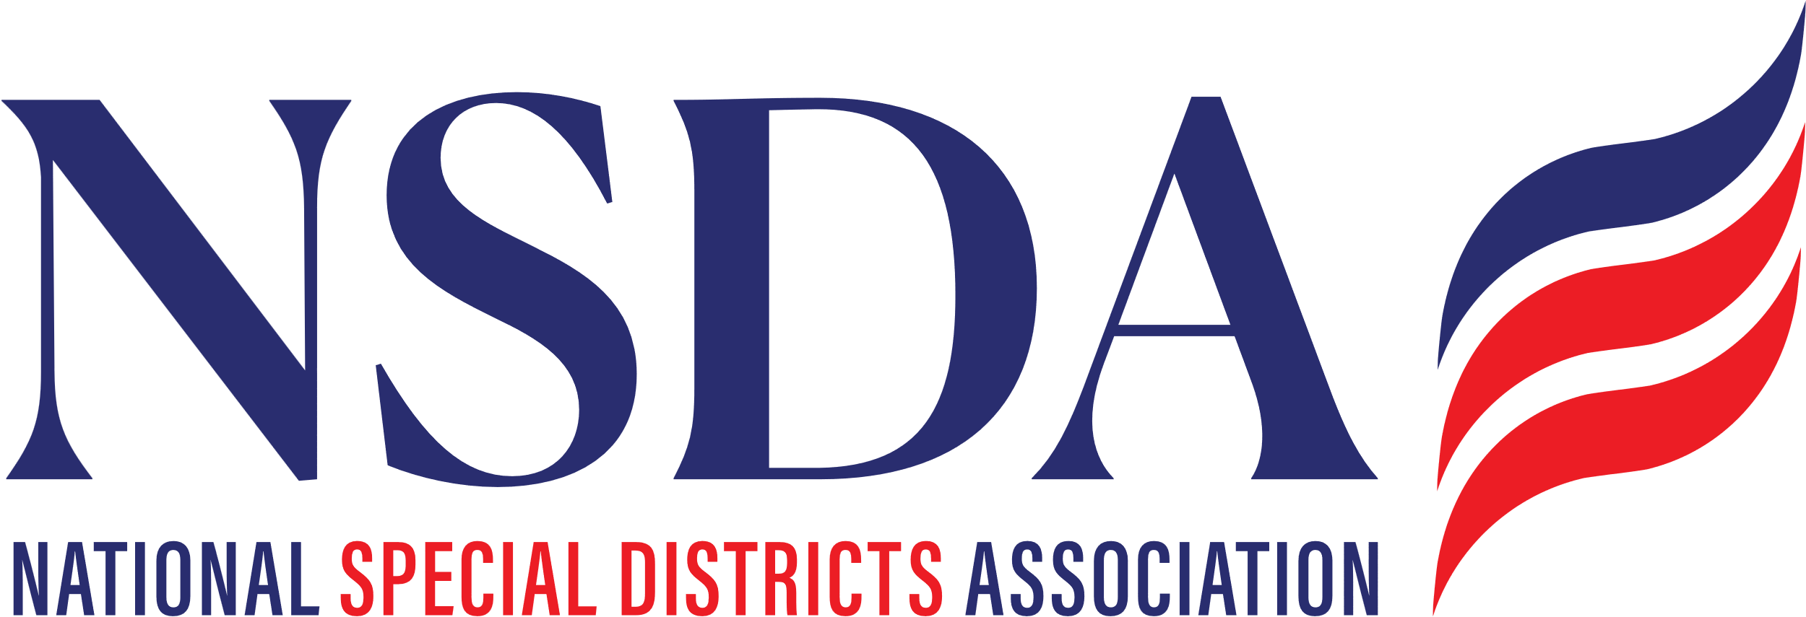 **your logo here**

[Date]

The Honorable __________

U.S. House of Representatives

_______ House Office Building

Washington, D.C. 20515

**RE: Cosponsor Request – *Special District Fairness and Accessibility Act H.R.2766***

Dear Representative ________:

On behalf of _________, we respectfully request that you cosponsor the *Special District Fairness and Accessibility Act* (H.R. 2766). This important bipartisan bill would establish a formal definition of “special district” in federal law and require the Office of Management and Budget (OMB) to issue guidance to federal agencies requiring special districts to be recognized as local governments.

[Brief description of your district.]

Special districts are at the heart of the trust equation as local governments created by the people of a community to deliver specialized services essential to their health, safety, economy, and well-being. In Your State, there are over XXX special districts championing local solutions and providing a broad range of essential services and infrastructure highlighting the importance of local governance, essential to local communities, vital to our nation.

Despite the significance of special districts throughout the United States, federal law lacks a consistent definition of these special purpose units of local government. As a result, some communities served by special districts face challenges in accessing federal funding opportunities as their local service providers are commonly omitted from the definition of eligible units of local government in legislative proposals that authorize federal programs and funding. Moreover, special districts lack official population figures and are therefore not recognized by the U.S. Census Bureau as “geographic units of government.” As a result, special districts are unable to gain access to certain resources.

Sponsored by Representatives Pat Fallon (R-TX) and Brittany Pettersen (D-CO), the bipartisan *Special District Fairness Act* represents a bipartisan effort designed to ensure that special districts have the same access to federal programs as other units of local government. Again, we urge you to cosponsor this important legislation and we ask that you work with your House colleagues to prioritize its passage.

Respectfully,

[Name]

[Title]

cc: Representative Pat Fallon

Representative Brittany Pettersen