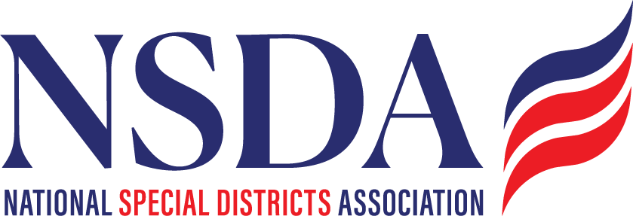
Board Resolution Establishing the Inaugural National Special District Day Resolution No. 2026-01
A Resolution of the Board of Directors of the National Special Districts Association Establishing May 6, 2026 as the Inaugural National Special District Day
WHEREAS, special districts are vital units of local government that provide essential public services including fire protection, water and sanitation, healthcare, parks and recreation, libraries, transportation, conservation, and other specialized services that improve quality of life and strengthen communities across the United States; and
WHEREAS, the National Special Districts Association (NSDA), incorporated as a national association in January 2025, serves as the unified national voice for special districts and advances policies, partnerships, and education that support effective, accountable, and community-focused local services; and
WHEREAS, NSDA represents more than 10,000 members and advocates for nearly 40,000 special districts nationwide, building a growing national network dedicated to supporting local service providers and the communities they serve; and
WHEREAS, through the national Districts Make the Difference educational campaign, NSDA has elevated awareness of the essential services provided by special districts by producing more than 200 educational videos and generating widespread social media engagement, highlighting the leadership and impact of districts across the country; and
WHEREAS, NSDA leads national federal advocacy efforts to ensure equitable treatment of special districts in federal programs, including support for the Special District Fairness and Accessibility Act (H.R. 2766 / S. 2014), legislation that would establish a formal federal definition of special districts and improve access to federal resources; and
WHEREAS, NSDA leaders and member districts have met with more than 100 congressional offices to educate policymakers about the critical role special districts play in delivering local services; and
WHEREAS, NSDA supports special districts in preparing for federal funding opportunities while helping ensure federal programs are structured to better serve special districts and the communities they support; and
WHEREAS, special districts embody local leadership, volunteerism, innovation, and responsive governance tailored to the needs of the communities they serve;
NOW, THEREFORE, BE IT RESOLVED, that the Board of Directors of the National Special Districts Association hereby proclaims May 6, 2026, as the Inaugural National Special District Day, recognizing the essential role special districts play in delivering local services that strengthen communities across the United States; and
BE IT FURTHER RESOLVED, that NSDA encourages special districts, state associations, community partners, and public officials nationwide to celebrate National Special District Day through education, outreach, and engagement activities that highlight how Districts Make the Difference; and
BE IT FURTHER RESOLVED, that this inaugural National Special District Day coincides with NSDA’s Districts Days in Washington, D.C., bringing district leaders from across the country together to engage with Congress and advocate for policies that support the essential services provided by special districts.
Adopted this ____ day of __________, 2026.
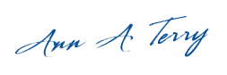

Board Chair
National Special Districts Association

