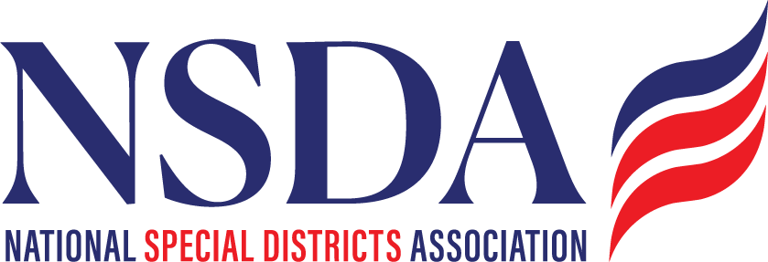

NSDC Federal Advocacy Committee
Agenda
10.23.2025
1:00 pm MNT time

https://us06web.zoom.us/j/85240694788?pwd=cFaB1TfCFa370f9hHB8T7easZI2uc1.1

Meeting ID: 852 4069 4788
Passcode: 818259
One tap mobile
+17193594580,,85240694788#,,,,*818259# US
+13462487799,,85240694788#,,,,*818259# US (Houston)

Welcome and Updates: Ann Terry
Federal Advocacy Update: Paragon Government Affairs

- FY 2026 Appropriations / Continuing Resolution (CR) Update (Whole Team)
- H.R. 2766 S.2014 Update (Jeff)
  - Previous Leg Activity- Tracked Bills
    - H.R. 4669 FEMA (Hasan)
    - H.R. 5078 Cybersecurity (Jeff)
- Other Advocacy Efforts
  - Special Districts House Caucus Request
  - Special Districts National Day Request
  - NSDA Fly-In Date – Pending 2026 Congressional Calendar Release in Nov. (expected April 27-1st or May 2-8)

- October kick off work on 2026 agenda (Chantal Unfug)
- Draft review, feedback of the 2026 agenda for Board adoption in November/December

- NSDA 5 Year Policy Roadmap process discussion to kick off October meeting (Clark Halvorson, WAWSD)

Members’ new items questions or discussion

Next meeting date: November and December are on holidays. Cancel?

Paragon Government Relations Hill visits - October

Wed 10/22
- Senator Ashley Moody R-FL (Wed 10/22 1-1:30)
  - Meeting with Bea Valenti
  - Location: SR-387 Russell Seante Office
- Rep. Pettersen D-CO-07 (Wed 10/22 2-2:30)
  - Meeting with Risa Fish
  - Location: 348 Cannon House
- Rep. Ralp Norman R-SC-05 (Wed 10/22 2:30-3)
  - Meeting with Darcy Sims
  - Location: 569 Cannon House
- Senator John Cornyn R-TX (Wed 10/22 3-3:30)
  - Meeting with Albert Bryson
  - Location 517 Hart Senate Office
- Senator Ruban Gallego D-AZ (Wed 10/22 4-4:30PM)
  - Meeting with Zack Gallego
  - Location: 302 Hart Senate Office
Thurs 10/23
- Fireside chat with Senator Lankford (Thurs 10/23 8-9:15)
  - Agenda
    - Breakfast (8am)
    - Fireside Chat (8:30-9am)
    - Networking (9-9:15am)
  - Location: American Trucking Association; 430 1st street, Suite 100
- Rep. Pat Fallon R-TX-04 (Thurs. 10/22 10:30-11AM)
  - Meeting with Rohan Suri
  - Location: 2416 Rayburn
- Rep. Ken Calvert R-CA-41 (Thurs. 10/23 11-11:30)
  - Meeting with Jack Lincoln
  - Location: 2205 Rayburn
- Placer County Business Association Summit (Thursday 10/23 noon-3PM)
  - Agenda
    - Lunch (12-1:15)
    - Speakers (1:15-2:15)
    - Speaker James Zandstra (2:15-3PM)
  - Location: Kimpton Hotel Monaco, 700 F St. NW
- NSDA Monthly Leg Call (Thursday 10/23 3-4PM)
  - Agenda:
  - Location: Zoom Call
- Senator Hickenlooper D- CO (Thursday; 10/23 4:30-5PM – TEAMS CALL)
  - Meeting with Christine Chang
  - Location: Teams Call
  - Phone: 202-224-5941

Friday 10/24
- Senator Tim Scott R-SC (Friday 10/24; 10:30-11am)
  - Meeting with Sam Llewellyn
  - Location: 104 Hart Building
  - Phone: 202-224-6121
- Rep. Mike Flood R-NE-01(Friday, 10/24; 11-11:30) Pending
  - Meeting with Joshua McGuire
  - Location: 343 Cannon House Building
- Rep. Kevin Kiley R-CA-03 (Friday 10/24 12-12:30)
  - Meeting with James Zandstra
  - Location: 2445 Rayburn
- Rep. Paul Gosar R-AZ-09 (Friday 10/24 1:30-2PM)
  - Meeting with Connor Sloan and Macayle Fuchs
  - Location: 2057 Rayburn

Monday 10/27
- Senator Rick Scott R-FL (Monday 10/27 3:30-4PM)
  - Meeting with Emily Dudley
  - Location: 110 Hart Senate
- Rep. Fong R-CA-20 (Monday 10/27; 4-4:30PM)
  - Meeting Kati Albiani
  - Location: 243 Cannon House

