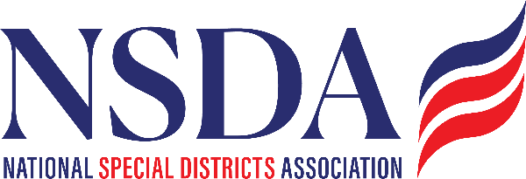

NSDA Federal Advocacy Committee
Meeting Summary
Date: April 23, 2026

Welcome and Updates – Ann Terry
Ann Terry opened the meeting with brief welcome remarks and general updates.

Federal Advocacy Update
Manatt, Phelps & Phillips, LLC & Chantal Unfug
Powerpoint provided

Special District Fairness and Accessibility Act of 2026
- The bill continues to move forward, with ongoing engagement in Congress post Committee Mark – up passage 32-8. Reviewed Congressional votes.
- Advocacy efforts remain focused on ensuring special districts are eligible for federal funding opportunities.
- Reviewed more details of current Congressional support in powerpoint
- Western Fire Chiefs support and presentation in DC was successful – the Bill was their 3rd top priority for the fly in

Issues / Hot Topics

DHS Shutdown Continues and Contingency Planning
- Appropriations have not yet been finalized, creating uncertainty and marks ups are happening now.
- A contingency plan is needed in the event of a shutdown, negotiations focus on cutting funding.

Farm Bill
- Timing of our Fly in is good. At this time this is mostly opposed by Democrats due to cuts in SNAP etc. Reminder this expired in 2023.
- Good Neighbor Authority is in the bill and being debated.
- Approximately 80 programs (Rural Development, wildfire suppression etc) tied to the Farm Bill are currently expired or awaiting reauthorization.
- Key issue: securing funding levels and program continuity.

Fix Our Forests / Water for Firefighting
- Continued focus on wildfire mitigation and forest management.
- Looking for a vehicle to attach to because it can’t move on its own.
- NSDA language is included.

Permitting Reform
- Remains a priority issue; discussions ongoing at the federal level with hostility toward renewables from previous administration.

WRDA / Water Infrastructure
- BASICS ACT - Water infrastructure investments continue to be a key area of focus. Currently being drafted but timing is unclear
- Padilla is looking for an EPA bill to attach Water for Firefighting to.

Surface Transportation
- IIJA concludes Sept ‘26, so discussions about keeping some programs is ongoing; tied closely to broader infrastructure priorities.
- Lots of funding has already been released, more to come but not at the same previous levels.

Congressional Budget & Appropriations
- Budget environment remains tight, with continued reliance on continuing resolutions (CRs). Marks Ups happening now and negotiations about cutting continue.
- Federal grants and funding are moving, but have seen bottle necks across the county. It appears there isn’t much to do but advocate and push for release. Manatt has seen the release, it is just slow. For example, Hazard Mitigation, EMPG, and DOE energy grants have had multiple delays until the deadlines are too short for local governments to start projects. Chantal will call NEMA to check in on their advocacy efforts.

Tax Policy (including nonprofits)
- Monitoring potential changes impacting nonprofit organizations.
- Broader tax negotiations tied to budget and reconciliation discussions.

Additional note: Success in Library funding advocacy.

Agency and Administrative Actions

Forest Service Reorganization
- Reorganization underway – moving HQ and regional offices to Utah
- Concerns raised about reduced staffing and capacity challenges.
- Potential impacts on program delivery and partnerships.

FEMA Review Council
- Final meeting of the FEMA Review Council held. May 7th is an estimated release of final recommendations.
- FEMA is expected to implement recommendations moving forward.

Special Districts’ Days Fly-in / National Special District Day (May 6)
- Reviewed the itinerary and outreach strategy.
- Executive Planning Meeting Friday April 24.
  - Overall agenda and structure are in good shape. Itinerary and agenda will go out about May 1st
  - Reception: May 5th hosted by TSDC
    - A “cocktail-style” Cinco De Mayo format celebration
    - Dinner on our own
  - Dinner event: May 6th Osteria Marini

Motion to Adjourn:
Legrand Bitter moved to adjourn
Michael Valdez seconded
Unanimous approval

