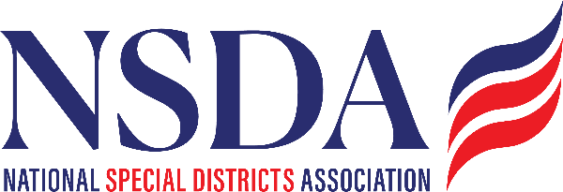 your logo here

Resolution Recognizing National Special District Day
A Resolution Recognizing May 6, 2026 as National Special District Day
WHEREAS, special districts are local governments that provide essential public services such as fire protection, water and sanitation, healthcare, parks and recreation, libraries, transportation, and other specialized services that enhance the safety, health, and quality of life of communities; and
WHEREAS, special districts play a vital role in meeting local needs through focused governance, community leadership, and responsible stewardship of public resources; and
WHEREAS, the National Special Districts Association advocates for nearly 40,000 special districts nationwide, working to elevate awareness and strengthen the role of districts in serving communities; and
WHEREAS, the national Districts Make the Difference campaign highlights the services, leadership, and community impact of special districts across the United States; and
WHEREAS, recognizing the contributions of special districts helps promote public awareness of the essential services districts provide every day;

NOW, THEREFORE, BE IT RESOLVED, that the [District/Organization Name] hereby recognizes May 6, 2026, as National Special District Day and joins communities across the nation in celebrating the vital role special districts play in delivering essential local services; and

BE IT FURTHER RESOLVED, that [District/Organization Name] encourages residents, community partners, and public officials to learn more about special districts and the important work they perform to strengthen communities.
Adopted this ____ day of __________, 2026.

Board Chair / President

Clerk / Secretary

