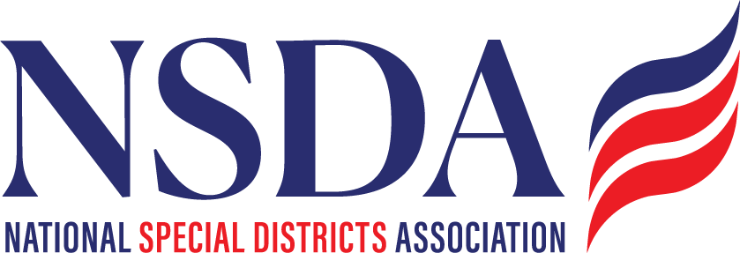
NSDA Federal Advocacy Committee Agenda
5.28.26 1:00 pm MNT time

https://us06web.zoom.us/j/85240694788?pwd=cFaB1TfCFa370f9hHB8T7easZI2uc1.1
Meeting ID: 852 4069 4788 Passcode: 818259
One tap mobile:
+17193594580,,85240694788#,,,,*818259# US
+13462487799,,85240694788#,,,,*818259# US (Houston)

Welcome and Updates: Ann Terry

Federal Advocacy Update: Manatt Phelps and Phillips, LLC & Chantal Unfug
- Special Districts Fly-in Recap:
  - Additional Cosponsors
  - Outreach to county organizations in member states

- Surface Transportation Reauthorization
- FEMA Review Council report
- New PFAS rules
- Appropriations status update
- Housing Update

Other:
- SBA: Feedback on letter regarding ADA Accessibility rules
- Planning for 2027:
  - Special District Day 2027
  - Fly In Summit
  - Platform planning will begin August 2026
- Committee feedback: Are there other issues to take positions on or do social media about?

