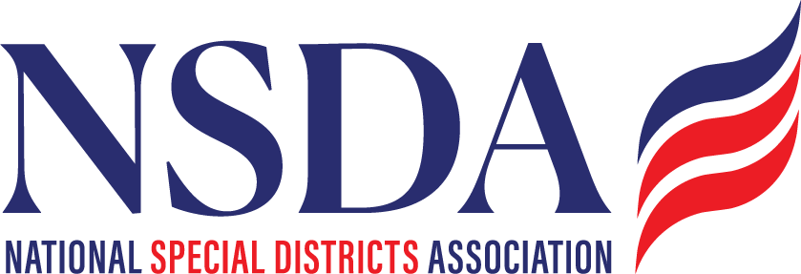

NSDA Federal Advocacy Committee Update
Summary Memo
2.26.26

Attendees:

Michael Valdez, Anthoney Sandoval
Kyle Packham, Mustafa Hesssabi, Glen Jacobs
David Ulbricht
Jarred Jones
Dean Edson
Angela Weeks-Semaine
Chantal Unfug, NSDA
Paragon Representatives
TFG Representative

Overview: Paragon
Federal activity remains fluid and politically constrained. A temporary Department of Homeland Security (DHS) shutdown, partisan Farm Bill negotiations, and ongoing Senate procedural hurdles are affecting multiple programs relevant to special districts. While several items are advancing, most face delays tied to broader political dynamics rather than substantive opposition to special district priorities.

Legislative Priorities & Key Updates
1. Special District Fairness and Accessibility Act
House
- Original plan to bypass committee and move directly to the floor was blocked by House Freedom Caucus members.
- The bill will now move through House Oversight Committee markup, expected soon possibly March (date pending confirmation).
- Reminder: In the 118th Congress, the bill passed Oversight 38–2 and the full House 352–27.

Senate
- Senator Rand Paul remains a potential obstacle, either through committee control or procedural holds.
- Strategy remains: advance through the House again and continue Senate engagement rather than delay action.

Action Items
- Prepare rapid outreach to House Oversight Committee members once markup is confirmed. (Joe/Chantal)
- Members with Representatives on Oversight should contact offices urging a YES vote. (all members)
- Re-engage national coalition partners for support letters. (Chantal)
- Provide concrete district examples demonstrating access barriers to federal programs. (Board members)
- Elevate veteran-focused district examples (e.g., Veterans Memorial Districts) as persuasive case studies. CA has offered a leader to support this effort on calls or in meetings. * Request of all members states – are there Veterans Memorial Districts in other states? Please ping Chantal

2. House Farm Bill (Forestry Title)
Status
- Markup expected next week.
- Debate is highly partisan, largely due to SNAP and pesticide provisions.
- Senate language has not yet been released.
Key Win
- Special district definition language is included in the forestry title.
- Expansion of Good Neighbor Authority eligibility to special districts is included.

Action Items
- Monitor markup outcome. (Paragon)
- Review distributed citation language once provided and create a social media post (Chantal)
- Continue tracking Senate developments.

3. Major Infrastructure Reauthorizations
Water Resources Development Act (WRDA)
- Biennial reauthorization pending.
- Hearings underway; no markup yet.
Clean Water & Drinking Water State Revolving Funds
- Authorization expires at year’s end.
- Active advocacy from water sector stakeholders.
Surface Transportation Reauthorization
- Focused surface transportation bill (not a broad infrastructure package).
- Important to transit and road districts.
- Hearings underway; no markup yet.
Action Items
- Continue monitoring hearings and draft language.
- Coordinate with water and transportation partners.

4. Water Infrastructure for Firefighting
- Senator Padilla preparing legislation (standalone bill expected).
- Coalition letter anticipated upon introduction.
Action Items
- Review draft bill when released.
- Consider NSDA participation in coalition sign-on.

5. Housing for the 21st Century Act
- Passed House 390–9.
- Focuses on regulatory streamlining and manufactured housing incentives.
- Senate Majority Leader Thune filed cloture; may move if 60 votes secured.
- Incremental reform; not landmark legislation.
Action Item
- Monitor Senate floor action for any impacts to Districts

6. Energy Choice Act
- ~157 House cosponsors (primarily Republican).
- Seeks to prevent state/local bans on specific energy hookups (e.g., natural gas).
- Likely to pass House; faces steep Senate hurdles.
- Highly partisan issue tied to local authority over energy policy.
Action Item
- Monitor for potential impacts on utility and energy districts.

FEMA & DHS Issues
Hazard Mitigation Grant Program (HMGP)
Current Situation
- Significant bottleneck; funds appear frozen.
- Reports indicate FEMA communication delays and possible administrative holds.
- DHS shutdown has compounded delays.
- Both Republican and Democratic congressional offices report difficulty obtaining information.
Key Concern
- Some districts face expiring periods of performance and risk losing funds.
Observations
- FEMA delays are not entirely new; bureaucratic backlogs are common.
- Delays may be exacerbated by political factors and DHS funding disputes.
- When released, funds often clear in batches without warning.
Action Items
- Collect specific district examples of: (Members)
  - Delayed disbursements
  - Expiring performance deadlines
  - Projects at risk
- Encourage bipartisan congressional letters to DHS/FEMA raising concerns. (Associations)
- Monitor upcoming FEMA oversight hearings for opportunities to raise questions. (Paragon)

Rural Health Transformation Program
Overview
- $50 Billion national program; limited funding relative to need.
- States received initial disbursements; implementation unclear.
- CMS must review state distribution plans.
- States may design internal distribution models, pending federal approval.
- Significant confusion at state and congressional levels regarding process.
Key Issues
- Lack of clarity on application and approval pathways.
- CMS inexperienced in administering grant-style programs.
- States may be cautious due to compliance concerns.
- Some stakeholders question overall program scale and impact.
Action Items
- Update and redistribute memo outlining: (Kristi More/Chantal)
  - Current state participation status
  - Known distribution processes
  - CMS approval framework
  - Key contacts and 3 questions/decision points
- Clarify what is known vs. unknown.
- Provide guidance on appropriate advocacy targets (state vs. federal). (Paragon)

Permitting Reform
- Bipartisan interest continues, but no unified legislative path.
- SPEED Act under discussion.
- Could move through transportation reauthorization, forestry vehicle, or standalone bill.
Action Item
- Monitor proposals affecting NEPA streamlining and project timelines.

