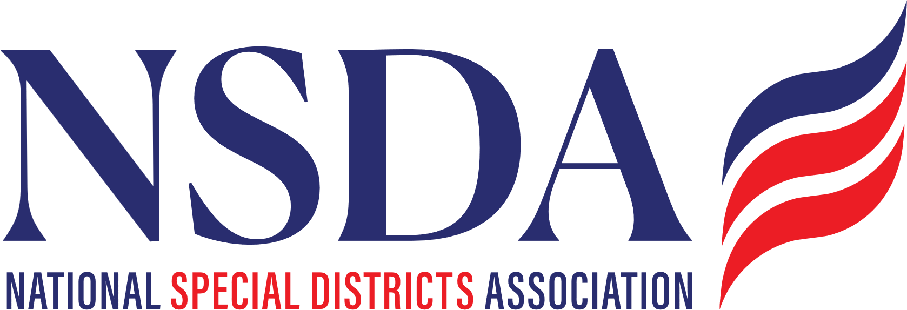

ACTION ALERT
Talking Points

Special District Fairness and Accessibility Act of 2026 (S.2014)
August 2026

The Special District Fairness and Accessibility Act of 2026 (S.2014) is cosponsored at this time by Sen. John Cornyn (R-TX), Sen. Jeff Merkley (D-OR), Sen. Ruben Gallego (D-AZ), Sen. Bernie Moreno (R-OH), and Sen. John Curtis (R-UT).

The bill will codify a first-ever, formal definition of “special district” and would require the White House Office of Management and Budget (OMB) to issue guidance to federal agencies requiring special districts to be recognized as local governments for the purpose of accessing Federal programs and to create consistence among Federal agencies.

Requested Action
- All Special District stakeholders are encouraged to send a Co-Sponsor request letter to their Senators.
- Special districts and partnering stakeholders with a direct connection to Kentucky/Senator Rand Paul are urged to contact Senator Paul’s office to urge him to support S.2014.

Additional Background & Talking Points
H.R. 2766, the Special Districts Fairness and Accessibility Act of 2026 and its Senate companion, S. 2014, have reached a pivotal stage in Congress. In March, H.R. 2766 successfully passed the House Committee on Oversight and Government Reform with strong bipartisan support. As the bill heads to the full House, it is facing procedural headwinds due to the congressional calendar and election-year scheduling.
We need to continue building a broad bipartisan coalition of House and Senate supporters to assure congressional leadership that there is strong support for the bill.
The encouraging news is that the Congressional Budget Office (CBO) has officially confirmed there is no fiscal impact associated with H.R. 2766. The bill simply creates a singular definition of special districts in federal law. At the same time, the legislation:
- Does NOT increase direct spending.
- Does NOT increase on-budget deficits.
- Does NOT trigger pay-as-you-go procedures.
- Does NOT create intergovernmental mandates.
- Does NOT create private-sector mandates.

This legislation does not create a new federal program, authorize additional federal spending, or impose new regulations. Instead, it establishes a consistent federal definition of special district, ensuring these local governments are appropriately recognized as intergovernmental partners by federal agencies when administering existing federal programs and funding opportunities.
- Examples of program ineligibility / barriers to access include:

    - Transportation Alternatives / Rails-to-Trails
    - USDOT’s Reconnecting Communities Program
    - U.S. Department of Agriculture (USDA) Rural Housing Preservation Grants
    - U.S. Environmental Protection Agency’s (EPA) Clean-Heavy Duty Vehicles Program

