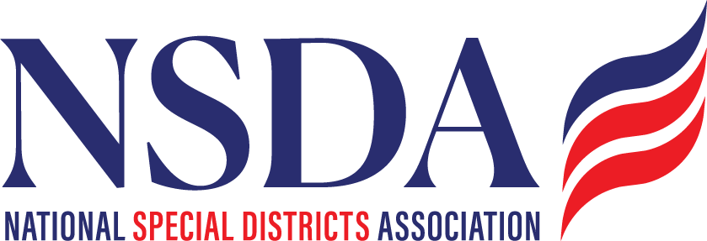

Federal Advocacy Program
2026
For board adoption

Objectives
- Advocate on Federal Policy and Funding
    - Influence federal legislative and regulatory actions as the voice for all special districts
    - Promote special district access to federal funding opportunities
    - Build strong, collaborative relationships with National Association partners

    - Access Funding
    - Ensure awareness and readiness to compete for funding opportunities
    - Track, communicate, and support federal funding opportunities

- Communicate the value of Special Districts
    - Increase awareness and understanding of special districts and NSDA among federal policymakers and the greater public
    - Strengthen relationships with partner advocacy organizations

- Educate NSDA Members to be effective
  - Track and inform federal legislative and regulatory matters of interest to all special districts
    - Ensure awareness of federal funding opportunities and equip members to effectively compete

Priorities for 2025/2026 (119th Congress)

National Definition of Special Districts/Special District Fairness and Accessibility Act
NSDA will work with key lawmakers, stakeholders and partners to advance legislation to establish a first-ever, formal definition of “special district” in federal law. This would also require the White House Office of Management and Budget to issue guidance to federal agencies requiring special districts to be recognized as local governments for the purpose of federal program determinations.

Public Finance
NSDA supports preserving, reinstating or expanding public financing tools that help special districts secure essential project funding. This includes reauthorizing Build America Bonds, expanding private activity bonds, restoring advance refunding bonds, and protecting the tax-exempt status of municipal bonds; it also includes active participation in the Public Finance Network on issues such as limiting costly mandates associated with the Federal Debt Transparency Act.

U.S. Census Bureau
After enacting the Special Districts/Special District Fairness and Accessibility Act, NSDA will work with Congress to direct sufficient resources to the U.S. Census Bureau to ensure that special districts are accurately counted in local government data sets, which are often critical to access federal funding opportunities.

Federal Funding Opportunities
NSDA will work to ensure that special districts are eligible for relevant discretionary and formula-based grant opportunities. Additionally, NSDA will advocate for dedicated technical assistance funding to help special districts navigate complex application processes and deliver projects more efficiently.

Congressional Caucuses
NSDA will advocate for creating a Congressional Caucus on Special Districts or aligning NSDA with existing relevant Caucuses. The effort would serve as a dedicated platform to educate lawmakers and federal agencies about the unique challenges and essential functions of special districts and the communities they serve across the nation.

Additional Issues to Monitor and Report

Administrative Functions:
NSDA will continue to monitor and report on policies, rules, and regulations that directly impact the administrative management of special districts.

Cybersecurity
NSDA supports federal programs and policies designed to bolster cybersecurity resilience through support and not through unfunded mandates. This includes advocating for initiatives that enhance threat detection, prevention, and response capabilities; promote best practices for data protection and privacy; and facilitate access to federal resources and training programs. NSDA will monitor, track and communicate compliance requirements.

Infrastructure
NSDA will broadly support and promote programs aimed at strengthening the United States’ critical infrastructure provided by Special Districts, including transportation and ports, water infrastructure, conservation, groundwater recharge, recycling, and storage solutions, and specifically water infrastructure for firefighting.

NSDA will support permitting reforms that streamline regulatory processes, reduce project delays, and lower costs associated with infrastructure development and maintenance, while maintaining a balanced approach that respects environmental protections.

Disaster Resilience, Readiness, Response, and Recovery
NSDA supports strengthening the resilience of special districts and the communities they serve. This includes advocating for federal programs and initiatives that would improve disaster preparedness and response, support local emergency management needs, and provide resources for infrastructure hardening, risk assessment, and recovery efforts and supporting policies and partnerships with stakeholders to advance shared goals. For example, NSDA has engaged on the Fix our Forest Act and will continue into 2026.

On Going Priority Reauthorizations
NSDA supports the timely and ongoing reauthorization of key legislation that sustains essential programs that strengthen rural development, enhance water infrastructure, promote conservation efforts, and improve disaster resilience. For example, support for the ongoing reauthorization of the Farm Bill is critical.

