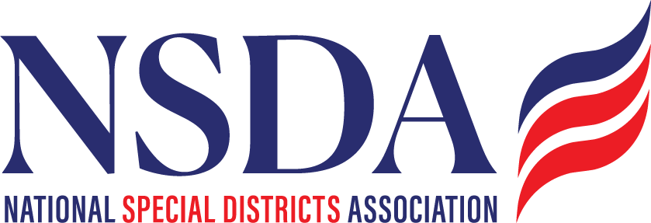

NSDC Federal Advocacy Committee Summary
1.22.26 1:00 pm MNT time

Welcome with Ann Terry Board Chair:
Announced Paragon Govt Relations is transitioning from the NSDA contract. RFP’s have already gone out to a select group of Lobbying firms. Goal is to present a contract by Feb 18th Board meeting. Ann thanked Joe and Team for everything they have done with us and for us!

Presented by: Paragon Government Affairs

Legislative & Budget Updates
Kickoff of the 2026 Legislative Session
- Congress is entering the 2026 session with an emphasis on bipartisan, “must-pass” legislation, particularly related to appropriations, infrastructure, wildfire resilience, and water resources.

Federal Budget & FY 2026 Appropriations
- A minibus funding package is expected to pass, totaling approximately $28 billion in discretionary funding with direct impacts on local governments and special districts.
- While not a full omnibus, the minibus reflects incremental progress and provides near-term funding certainty in key program areas, represents appx 70%, and the final 4 of 12 packages.
- Appropriations remain constrained, reinforcing the importance of clear, targeted advocacy tied to local impacts. For example, the ACA subsidies have stalled but won’t impact passage.

Priority Federal Policy Items
Special District Fairness and Accessibility Act
- Continued momentum around improving special districts’ access to federal funding and programs.
- NSDA remains actively engaged with congressional offices and partners to build bipartisan support and have been talking to sponsors. Staff turn over impacts the knowledge base, but not the support.
- Member engagement and sign-on efforts remain critical. Exciting to announce Western Fire Chiefs Association has signed on bringing almost 3000 Fire members.

Disaster Response/Recovery:
General FEMA:
- FEMA reforms continues – Task force still on hold; proposals include new grant programs, discussion on cost share allocations. Colorado will provide cost share analysis regarding local governments ability to pay.
Fix Our Forests Act (FOFA)
- Ongoing bipartisan interest in wildfire mitigation, forest health, and landscape-scale resilience.
- FOFA aligns with special district priorities related to fire protection, water, and land management. NSDA language is included.
Water Infrastructure for Firefighting Proposal
- NSDA is providing feedback on language. Discussion focused on strengthening water system capacity and infrastructure to support wildfire response within the States’ SRF thru the EPA.
- Emphasis on rural and high-risk areas where special districts play a frontline role.
- Proposal continues to gain traction as wildfire risks increase nationwide.
Padilla–Sheehy Wildfire Resilience Legislation (FIRE SMART ACT)
- Senators Padilla and Sheehy are advancing legislation centered on proactive wildfire resilience and preparedness within the USDA bill.
- The bill complements FOFA and broader wildfire policy efforts and kudos to NSDA for their multi year effort on this.
- Potential areas for NSDA alignment include infrastructure, local implementation, and interagency coordination.
Water Resources Development Act (WRDA) Reauthorization
- WRDA reauthorization remains a key vehicle for water infrastructure investment expected to pass. NSDA has the opportunity to support our national partners.
- Special districts have an opportunity to advocate for inclusion and eligibility in Corps-related projects.
Member Questions & Discussion (New Items Raised)
Members raised several additional policy questions for tracking and future advocacy consideration:
- Surface transportation reauthorization – timing, priorities, and implications for special districts.
- PFAS liability exemptions – potential impacts on water and wastewater districts is in the process.
- Creation of a U.S. Wildland Fire Service – discussion of concept, feasibility, and relationship to existing agencies.

Upcoming Advocacy Activity
DC Days / Fly-In
- Dates: May 4–7 (5th-6th ) meetings on the hill
- Location: Washington, DC
- Hotel: Navy Yard (same hotel for all participants)
- Action item: Confirm which members will attend in order to finalize meetings and logistics.

