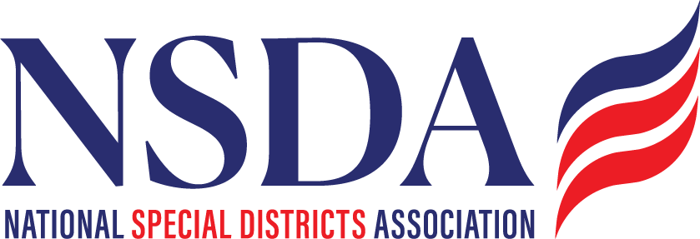

Dear NSDA Members,
On behalf of the Board of Directors of the National Special Districts Association (NSDA), I am pleased to announce the inaugural National Special District Day, to be celebrated on May 6, 2026 in coordination with our Special District Days event in Washington D.C., as we convene to advocate for all of you.
Special districts are essential to communities across the country—providing vital services such as fire protection, water and wastewater management, healthcare, parks and recreation, mosquito control, libraries, and more. Yet too often, the important role these local governments play in strengthening communities and supporting the national economy goes unrecognized.
National Special District Day is an opportunity to change that.
We invite every NSDA member organization, district, and partner to formally recognize May 6, 2026, by adopting the National Special District Day resolution and sharing it with your own members, boards, and communities. By doing so, we can collectively highlight the impact of special districts and elevate awareness of the critical services they provide every day.
This year’s celebration is especially meaningful as it coincides with NSDA’s Special District Days in Washington, D.C., when special district leaders from across the country will gather to meet with members of Congress and advocate for policies that support local service delivery.
In the coming weeks, NSDA will also launch a coordinated social media campaign leading up to and on May 6. We encourage you to help amplify the message by:
- Following NSDA on social media and
- liking, sharing, and reposting our National Special District Day content
- Highlighting the work of your districts using the resolution and social media examples we will provide
Together, we can ensure that communities, policymakers, and partners across the nation better understand and appreciate the essential role of special districts.
Thank you for your continued leadership and for helping us make the first-ever National Special District Day a powerful celebration of local service and community impact.
Sincerely,


Ann Terry
Chair, Board of Directors
National Special Districts Association

