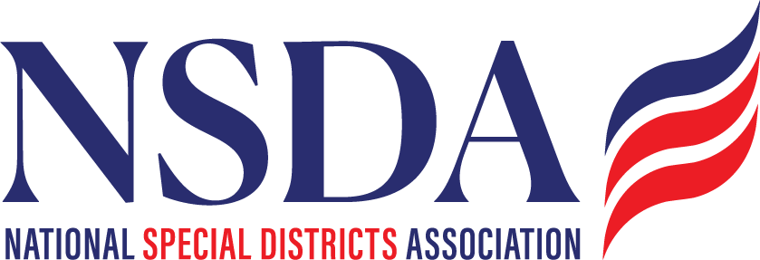

NSDA Federal Advocacy Committee Summary
3.26.26

Welcome and Updates
Ann Terry opened the meeting and welcomed participants and introduced representatives from Manatt, Phelps & Phillips, LLP, who will support NSDA’s federal advocacy strategy. Attendees introduced themselves, reflecting a strong and growing coalition of partners and stakeholders engaged in advancing special district priorities. Eve O’Toole, Mark Ritacco, Adrianna Williams and Lisa Brakovich. A huge thank you and shout out to Paragon!

Federal Advocacy Updates
Joe Krahn (Paragon Government Affairs) and Chantal Unfug (NSDA) provided an update on federal activities:
Special District Fairness and Accessibility Act of 2026 (H.R. 2766)
- The legislation continues to gain traction following committee advancement 32-8. Freedom Caucus members were 7 of the 8 No votes although we did get 3 “no votes from 2025” to yes.
- Advocacy efforts remain focused on building bipartisan support and preparing for House floor consideration on a suspension calendar, so the vote is T’d up. We continue to solicit cosponsors and encourage continues outreach.
- NSDA will be refreshing talking points with Manatt.

Special Districts’ Days in Washington, D.C.
- Dates: May 5–6, 2026
- National Special District Day: May 6, 2026
- Planning is underway for a coordinated fly-in with congressional meetings, national messaging, and partner engagement. NSDA will update the DC packet and material and will share in advance of the meeting. Chantal will send out a participants list and will create a group chat.
- Members are encouraged to amplify outreach efforts for our inaugural “Special Districts Day” through coordinated communications and social media. Chantal will be sending out marketing materials in April.

Fly-In and Partner Engagement Updates
- ASAE Community Impact Coalition Fly-In:
  - Kyle and Chantal attended per our membership in the Impact Coalition. Provided valuable exposure for NSDA priorities as an association and for association members.
Speaking engagements:
- National Association of Conservation Districts Fly-In – NSDA Update will be provided by Liz, Manatt) – Chantal to assist
- Western Fire Chiefs Fly-In - Ann Terry will attend and speak.

Federal Grants and Compliance Updates
- Executive Orders & SAM Registration:
  - Ongoing challenges persist with SAM.gov registration and renewals, including delays, verification issues, and proposed entity validation requirements.
  - Members reported confusion navigating system changes and compliance requirements.
  - While other National Associations are taking a position and providing individual letters, NSDA will not at this time.
- Grants.gov & GAO Research:
  - The Government Accountability Office (GAO) is continuing its review of Grants.gov accessibility and processes.
  - NSDA and TFG will provide input highlighting barriers faced by special districts, including eligibility clarity, system usability, and administrative burden.
- Key Issues Identified:
  - Limited access to federal funding due to inconsistent definitions
  - Administrative complexity in application processes
  - Need for improved technical assistance and streamlined systems

Next Steps
- Finalize logistics and materials for Special Districts’ Days in D.C.
- Continue targeted outreach in support of H.R. 2766
- Provide additional feedback to GAO on Grants.gov barriers
- Support members with SAM registration guidance and federal grant navigation when appropriate

