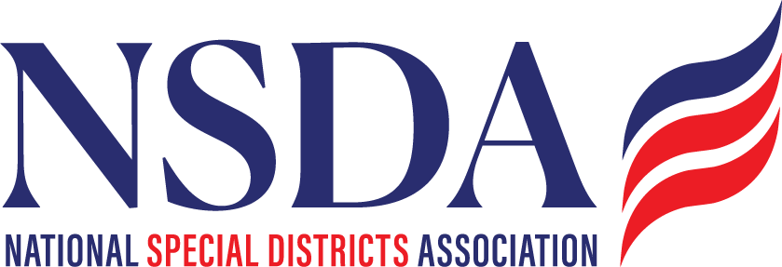

NSDA Federal Advocacy Committee Agenda
3.26.26 1:00 pm MNT time

https://us06web.zoom.us/j/85240694788?pwd=cFaB1TfCFa370f9hHB8T7easZI2uc1.1

Meeting ID: 852 4069 4788 Passcode: 818259
One tap mobile
+17193594580,,85240694788#,,,,*818259# US
+13462487799,,85240694788#,,,,*818259# US (Houston)

Welcome and Updates: Ann Terry
Introductions: Manatt Phelps and Phillips, LLC
Federal Advocacy Update: Paragon Government Affairs’ Joe Krahn & Chantal Unfug
- Special District Fairness and Accessibility Act
- Special Districts’ Days in DC: Update marketing
  - Trip May 5,6
  - National Special District Day May 6
- ASAE Community Impact Coalition Fly In summary
- NARD Fly In – Ann Terry

