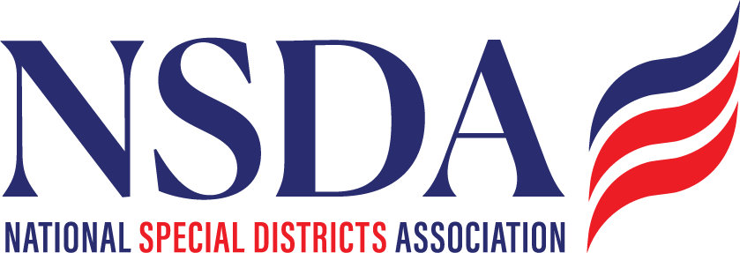

NSDC Federal Advocacy Committee

Agenda

4.24.2025

1:00 pm MNT time

[*https://us06web.zoom.us/j/85240694788?pwd=cFaB1TfCFa370f9hHB8T7easZI2uc1.1*](https://us06web.zoom.us/j/85240694788?pwd=cFaB1TfCFa370f9hHB8T7easZI2uc1.1)

*Meeting ID: 852 4069 4788*

*Passcode: 818259*

*One tap mobile*

*+17193594580,,85240694788#,,,,*818259# US*

*+13462487799,,85240694788#,,,,*818259# US (Houston)*

Welcome and Updates: Ann Terry

Federal Advocacy Update: Paragon Government Affairs

General Overview - Lawmakers Wrapping up pre-Memorial Day Push

* Budget Reconciliation Update
  + "One Big Beautiful Bill Act" (H.R. 1)
* Special District Fairness and Accessibility Act
* Creation of a Congressional Special District Caucus
* FEMA Reform Proposal - Draft Bill
* Private Equity Roll-ups of Fire Truck Manufacturers
* Regulatory Update on PFAS

Next meeting date: May 22, 2025